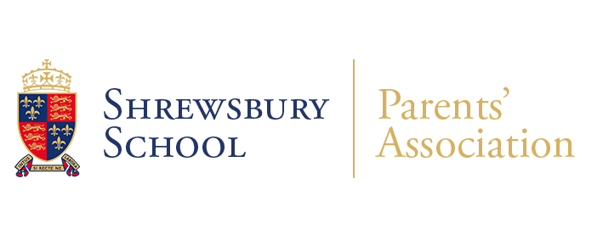**NOTICE OF ANNUAL GENERAL MEETING of the SSPA**

**NOTICE IS HEREBY GIVEN THAT THE Annual General Meeting (AGM) of Shrewsbury School Parents Association (SSPA) will be held on Tuesday 14th January 2025 at 19:00 in The Peterson Room, The Bursary, Shrewsbury School**

**All Parents are invited to attend the AGM.**

**AGM Agenda**

1. **Welcome and opening remarks from Kevin Brennan Deputy Head.**
2. **Apologies**
3. **Minutes**Approve Minutes of Meeting held on 9th January 2024
4. **Ordinary Business**
   1. **To receive** from Anne Barrett and Mary Cambray, Joint Chairs of SSPA, a report on the activities of the SSPA.
   2. **Adoption of Report**
   3. **To receive** from Vicki Tomlinson, Treasurer of SSPA, a report of the Financial Statements of the SSPA for the period 1st September 2023 to 1st September 2024.
   4. **Adoption of Accounts**
   5. **To ask for a volunteer to act** as Auditor/Independent Examiner to the SSPA for the ensuing year
5. **Election of Executive Committee**
   1. **Chairman (Anne Barrett & Mary Cambray)**
   2. **Vice-Chairman (Clare Butterton)**
   3. **Treasurer – (Vicki Tomlinson**
   4. **Secretary (Joycelin Hoyland)**
6. **AOB**
7. **Closing remarks Anne Barrett & Mary Cambray Joint Chair.**

**Dated: 26th November 2024**

**By order of the Executive Committee**

**Shrewsbury School Parents Association**

**sspa@shrewsbury.org.uk**